Date

Name

Title

Business

Street Address

City, STATE Zip

SUBJECT ALL CAPS

Dear Ms. Erin Chappell,

**Index Calculation**

The annual 20-mm Survey monitors the distribution and relative abundance of post-larval and juvenile Delta Smelt throughout their historical range. Nine week-long surveys are conducted every other week from mid-March through early July. Each survey samples a total of 47 stations: 41 “index stations” which have been sampled since the inception of the survey and 6 “non-index stations” in the North Delta which were added to the sampling regime in 2008. When water flows are high an additional 5 non-index stations are sampled in San Pablo Bay. Figure 1 showcases the location of all 20-mm stations.

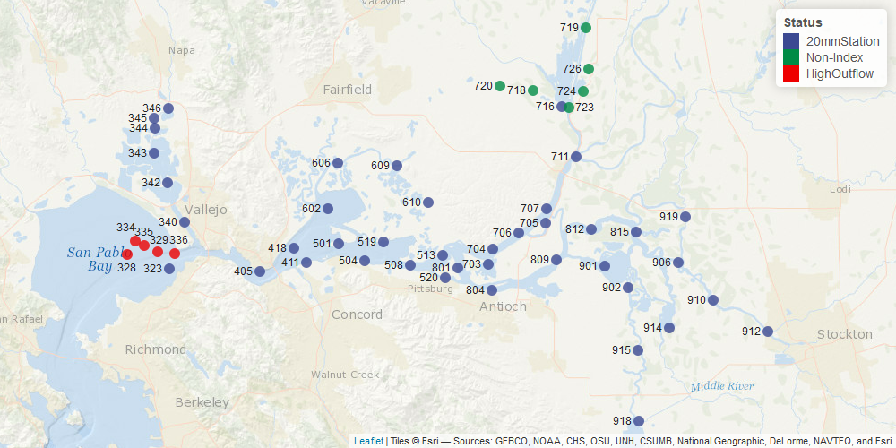

Figure 1. The locations of each 20-mm site.

To calculate the index, Delta Smelt catch at each station is standardized to a volume of 10,000 cubic meters (i.e., catch per unit effort, CPUE). The mean station CPUE is used to calculate the geometric mean of the four index surveys, which are summed to produce the annual index. The index surveys are comprised of the two surveys directly before and the two surveys directly after Delta Smelt mean fork length reaches 20 mm. Since the index is calculated using a geometric mean, both abundance and distribution can affect the magnitude.

**Changes to the Index calculations**

Beginning in the 2022 season, the index features several modifications to its calculations. All changes and calculations are documented in an R script[1] calculating the provided index values. These changes are:

1. the inclusion of the six “non-index stations” in calculating CPUE of each index survey,
2. the use of a dynamic fork length threshold to better describe post-larval and juvenile (young of the year, YOY) Delta Smelt,
3. the use of total number of Delta Smelt caught rather than the total number of Delta Smelt measured to calculate CPUE,
4. and the refinement of a zero index calculation.

Inclusion of the six “non-index stations”

The six “non-index stations” in the North Delta were previously disregarded from the index calculations to maintain the continuity of the index to the inception of the survey. The survey began in 1995 and these additional North Delta stations were added only in 2008. These stations are now being incorporated because sufficient years of data have been collected to determine that the inclusion of these stations does not change the overall status and trends of the index (Figure 2). The inclusion of these six additional stations will more accurately describe the status and trends of the Delta Smelt population across their historical range. This inclusion will also add consistency to the formulations, as these six stations are included when determining the mean fork length of the sample population (for the purposes of determining which surveys will contribute to the index).

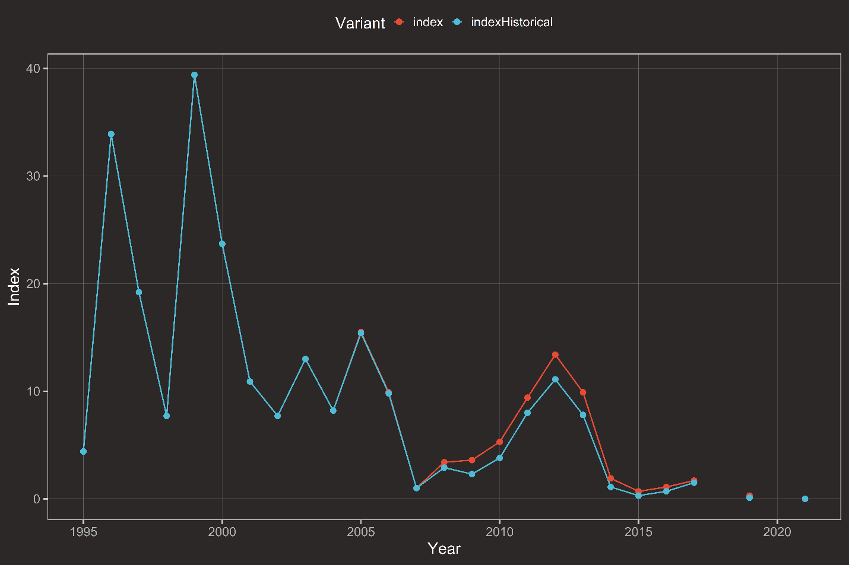

Figure 2. The 20-mm Survey index per year since the inception of the survey in 1995. The historically provided values is compared to the index values computed using the updated methods detailed in this document.

“Dynamic YOY fork length threshold”

Historically, the 20-mm Survey primarily captures YOY Delta Smelt given the timing of the survey and sampling gear design, but adults are sometimes captured as well. Since the Delta Smelt index is an indicator of production, adults are filtered out prior to calculating the index. Previously, this was done by applying a fork length cutoff of 60 mm across all months. However, in one case survey leads manually filtered an adult fish that was captured earlier in the year, even though it was below the length threshold. In March 1998 (Survey 1), an individual measuring 59 mm fork length was manually removed from the index calculation, since Delta Smelt life history indicates this fish was a spawning adult and inclusion of this individual would have meant that the mean length of the Delta Smelt population exceeded 20 mm twice. To better filter adults from YOY, a more dynamic threshold has been applied based on length-at-date plots of fish caught on the 20-mm Survey for the entire period of record[2]. The survey now has an adult Delta Smelt threshold of > 50 mm fork length from March to May, and > 60 mm fork length in June and July. This dynamic threshold will be continuously revisited as additional data is collected and more fish are caught.

“Using total number of fish caught to calculate CPUE”

Delta Smelt catch is standardized to CPUE before calculating the index value. In the Access database query, the number of fish measured is used for this calculation. Since the 20-mm Survey was designed specifically to inform Delta Smelt abundance and distribution, all individuals must be measured. Subsampling should not occur. Unfortunately, subsampling has occurred in two rare instances, station 340 in Survey 5 of 2006 and station 343 in Survey 6 of 2006 where only 50 Delta Smelt out of 55 and 67 fish, respectively, were measured. This resulted in an error in the index calculation. To prevent this error in the future, the number of fish caught, instead of the number of fish measured, will be used to calculate CPUE. In the rare event of subsampling, the length frequency distribution of the measured fish will be expanded to account for possible adult fish caught in the non-measured fish. A check will be added to the end of the year database quality control process to identify instances when the number of Delta Smelt measured does not equal the number of individuals caught; this check will help identify these rare occurrences and allow for immediate action for the affected samples.

“Incalculable and zero index”

In the entire period of record for the 20-mm Survey, there have been two instances when the Delta Smelt index is not calculable. This occurs when it is not possible to determine when mean Delta Smelt fork length reached 20 mm, either because catch is intermittent throughout the season or not enough sampling occurred. Since the 20-mm gear is most efficient for Delta Smelt around 20 mm in length, the index is calculated using only the four surveys around which the average length of Delta Smelt is 20 mm. Our ability to calculate an index is therefore dependent on determining when the average size of the Delta Smelt population is 20 mm. If there is inadequate catch throughout the 20-mm Survey season to determine when Delta Smelt averaged 20 mm, then an index is not calculable. This was the case in 2018 when catch only occurred in surveys 1-3 and survey 9. Having a gap in the length data presented a barrier to determining when the average size reached 20 mm, and thus we could not determine which surveys to use to calculate in the index. In 2020, sampling was put on hold and then reduced to minimum capacity due to COVID-19, making the index also incalculable for that year[3].

In contrast, 2021 was the first year the 20-mm Survey had a zero index. In 2021, catch was low throughout the 20-mm Survey season, and thus regardless of which surveys were used to calculate the index, the index was zero. Since the YOY Delta Smelt population has been in decline for many years and catches are likely to remain low (Figure 1), setting specific criteria about a zero index versus an incalculable index is appropriate. Going forward, an incalculable index will be produced when the 4 surveys contributing to the index is indeterminate (cannot detect when average length reaches 20 mm), and it is uncertain if the index should be zero. A zero index will be produced when 1) all surveys, sampled without any reduction in effort, have zero catch, and 2) the index is zero due to rounding and there is sufficient information to determine which surveys are used to calculate the index. A zero index is an appropriate description of the low abundance of the population if individuals are too rare to be commonly caught—a zero index does not, however, indicate an absolute abundance of zero for the species. Additional refinements will be continuously revisited as additional data is collected.

**Benefits of changes**

The 20-mm Survey Delta Smelt index from 2022 onward will incorporate these four discussed changes. These modifications will together 1) better describe catch of Delta Smelt throughout their historical range, 2) better describe YOY individuals, 3) be more robust to rare instances of subsampling, and 4) be more consistent in defining conditions of an incalculable or a zero index value. The incorporation of these changes does not meaningfully change the status and trends of the Delta Smelt population (Table 1).

Table 1. The 20-mm index values as calculated using the new methods compared to the previously provided values. The difference in 2005 is due to the inclusion of 2 additional DS in tow 2 of station 415 sampled on 2005-05-27 after the publication of the historical index, the difference in 2006 is due to subsampling instances for that year, and the difference from 2008 onwards is due to the inclusion of the six non-index stations.

| year | index | indexHistorical | indexDifference |
| --- | --- | --- | --- |
| 1995 | 4.4 | 4.4 | 0.0 |
| 1996 | 33.9 | 33.9 | 0.0 |
| 1997 | 19.2 | 19.2 | 0.0 |
| 1998 | 7.7 | 7.7 | 0.0 |
| 1999 | 39.4 | 39.4 | 0.0 |
| 2000 | 23.7 | 23.7 | 0.0 |
| 2001 | 10.9 | 10.9 | 0.0 |
| 2002 | 7.7 | 7.7 | 0.0 |
| 2003 | 13.0 | 13.0 | 0.0 |
| 2004 | 8.2 | 8.2 | 0.0 |
| 2005 | 15.5 | 15.4 | 0.1 |
| 2006 | 9.9 | 9.8 | 0.1 |
| 2007 | 1.0 | 1.0 | 0.0 |
| 2008 | 3.4 | 2.9 | 0.5 |
| 2009 | 3.6 | 2.3 | 1.3 |
| 2010 | 5.3 | 3.8 | 1.5 |
| 2011 | 9.4 | 8.0 | 1.4 |
| 2012 | 13.4 | 11.1 | 2.3 |
| 2013 | 9.9 | 7.8 | 2.1 |
| 2014 | 1.9 | 1.1 | 0.8 |
| 2015 | 0.7 | 0.3 | 0.4 |
| 2016 | 1.1 | 0.7 | 0.4 |
| 2017 | 1.7 | 1.5 | 0.2 |
| 2018 | 0.0 | NA | NA |
| 2019 | 0.3 | 0.1 | 0.2 |
| 2021 | 0.0 | 0.0 | 0.0 |

1. [*https://nrm.dfg.ca.gov/FileHandler.ashx?DocumentID=202704*](https://nrm.dfg.ca.gov/FileHandler.ashx?DocumentID=202704)
2. [*https://nrm.dfg.ca.gov/FileHandler.ashx?DocumentID=202706*](https://nrm.dfg.ca.gov/FileHandler.ashx?DocumentID=202706)
3. [*https://wildlife.ca.gov/Conservation/Delta/20mm-Survey/Bibliography*](https://wildlife.ca.gov/Conservation/Delta/20mm-Survey/Bibliography)